Allergen Statement Letter
March 1, 2023
Dear Customer,

This letter is to confirm that the products sold by Panoramic, LLC. do not contain any applicable ingredients that could cause an allergic reaction. These allergens include peanuts, soybeans, sesame, milk, eggs, fish, crustacean, tree nuts, and wheat, as well as gluten, soy products, dairy products, egg products, shellfish, and sulfites. Furthermore, it certifies that neither we, nor our suppliers, intentionally add any known allergens into our products. All our products have been manufactured in compliance with applicable Good Manufacturing Practices.

Thank you for your interest in our products.

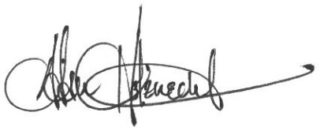

Adam Holznecht
Quality Assurance Manager

