Bisphenol A (BPA) Statement Letter

January 3, 2023

Dear Customer,

Panoramic, LLC. uses FDA approved polyester resins along with FDA approved food grade silicone (as a processing aid) in the manufacture of our plastic product(s). The materials most commonly used are: PET and RPET.

While we do not test for the presence of Bisphenol A, our raw material suppliers have provided certification that Bisphenol A is not used to manufacture, nor is intentionally introduced to, the materials that they supply to Panoramic, LLC. Furthermore, Panoramic LLC. does not add Bisphenol A as part of our manufacturing process.

“Bisphenol A (BPA) is a chemical building block that is used primarily to make polycarbonate plastic and epoxy resins. Over four decades of extensive safety research on BPA shows that consumer products made with BPA are safe for their intended uses and pose no known risks to human health.”

Thank you for your interest in our products.

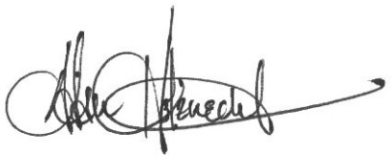

Adam Holznecht
Quality Assurance Manager

