Statement of Compliance

U.S. Federal Food, Drug, and Cosmetic Act

January 3, 2023

Panoramic, LLC. does hereby guarantee, as of the date of each shipment, that the article or articles that makeup each shipment hereafter made to the Buyer, or on the order of the Buyer, is on such date:

- Not adulterated or misbranded within the meaning of the U.S. Federal Food, Drug, and Cosmetic Act.
- May be introduced into interstate commerce under Sections 404 and 505 of the U.S. Federal Food, Drug, and Cosmetic Act.
- Not adulterated or misbranded within the meaning of the pure food or drug laws or ordinances of any U.S. state or city which are applicable to such shipment.
- Comply with all applicable and material U.S. Federal, State, and Local Law, including, but not limited to, the Consumer Product Safety Act and the Fair Labor Standards Act.

This agreement shall continue in effect and shall apply to all future dealings between Buyer and Seller until such time as Seller revokes it in writing.

Yours sincerely,
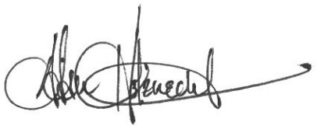

Adam Holznecht
Quality Assurance Manager

