Food Contact Packaging
Certificate of Compliance

January 3, 2023
Dear Customer,

This letter is to confirm that the products produced by Panoramic, Inc. are suitable for food contact and conform with USA FDA CRF 21 Section 177.1630 and are maintained through good manufacturing practices (CGMP CFR Title 21 Section 110).

Thank you for your interest in our products.

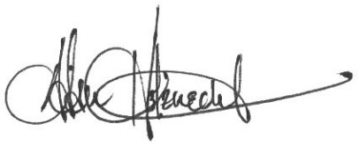

Adam Holznecht
Quality Assurance Manager

