Gluten Free Statement Letter
January 3, 2023

Dear Customer,

This letter is to confirm that the products sold by Panoramic, LLC. do not contain gluten. Furthermore, it certifies that neither we, nor our suppliers, intentionally add gluten into any of our products. All our products have been manufactured in compliance with applicable Good Manufacturing Practices.

Thank you for your interest in our products.

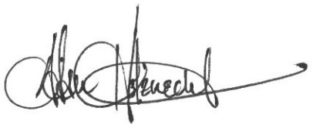

Adam Holznecht
Quality Assurance Manager

