Ozone Depleting Substances Statement Letter

January 3, 2023

Dear Customer,
Panoramic, LLC. uses FDA approved polyester resins along with FDA approved food grade silicone (as a processing aid) in the manufacture of our plastic product(s). The materials most commonly used are: PET and RPET.

Panoramic, LLC does not intentionally add any ozone depleting substances, including chlorofluorocarbons (CFCs), hydrochlorofluorocarbons (HCFCs), halons, methyl bromide, carbon tetrachloride, hydrobromofluorocarbons, chlorobromomethane, and methyl chloroform to our products. While we do not test for the presence of the listed substances, our raw material suppliers have provided certification that no ozone depleting substances are used to manufacture, nor are intentionally introduced to, the materials that they supply to Panoramic, LLC.

Thank you for your interest in our products.

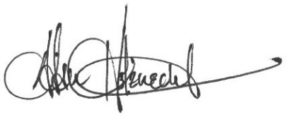

Adam Holznecht
Quality Assurance Manager

