Perfluoroalkyl and Polyfluoroalkyl Substances (PFASs) Statement Letter

January 3, 2023

Dear Customer,
Panoramic, LLC. uses FDA approved polyester resins along with FDA approved food grade silicone (as a processing aid) in the manufacture of our plastic product(s). The materials most commonly used are: PET and RPET.

While we do not test for the presence of per and polyfluoroalkyl substances (PFASs), our raw material suppliers have provided certification that per and polyfluoroalkyl substances (PFASs) are not used to manufacture, nor intentionally introduced to the materials that they supply to Panoramic LLC. Furthermore, Panoramic, LLC. does not add per and polyfluoroalkyl substances (PFASs) as a part of our manufacturing process.

Thank you for your interest in our products.

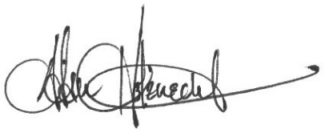

Adam Holznecht
Quality Assurance Manager

