Proposition 65 Statement Letter

January 3, 2023

Dear Customer,
Panoramic, LLC. uses FDA approved polyester resins along with FDA approved food grade silicone (as a processing aid) in the manufacture of our plastic product(s). The materials most commonly used are: PET and RPET.

The PET materials used in our PET and RPET products are believed to be in compliance with California’s Safe Drinking Water and Toxic Enforcement Act (Proposition 65) restrictions on “known carcinogens and reproductive toxicants.” While we do not test for the presence of these chemicals; our raw material suppliers have provided certification that none of the listed chemicals are used to manufacture, nor are intentionally introduced to, the materials that they supply to Panoramic, LLC. Furthermore, Panoramic LLC. does not add any of the listed chemicals as part of our manufacturing process.

Thank you for your interest in our products.

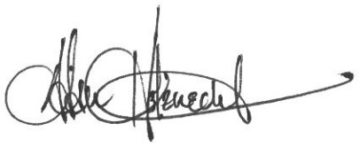

Adam Holznecht
Quality Assurance Manager

