Statement of Origin

January 3, 2023

Dear Customer,

This letter is to confirm that the products sold by Panoramic, LLC were manufactured in the United States.

Our manufacturing facility is located at 1500 North Parker Drive in Janesville, Wisconsin 53545 USA.

The raw materials that our used to produce our products are sourced and manufactured from plants primarily located in the United States.

Thank you for your interest in our products.

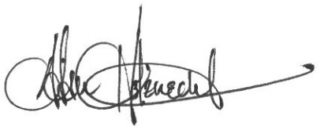

Adam Holznecht
Quality Assurance Manager

